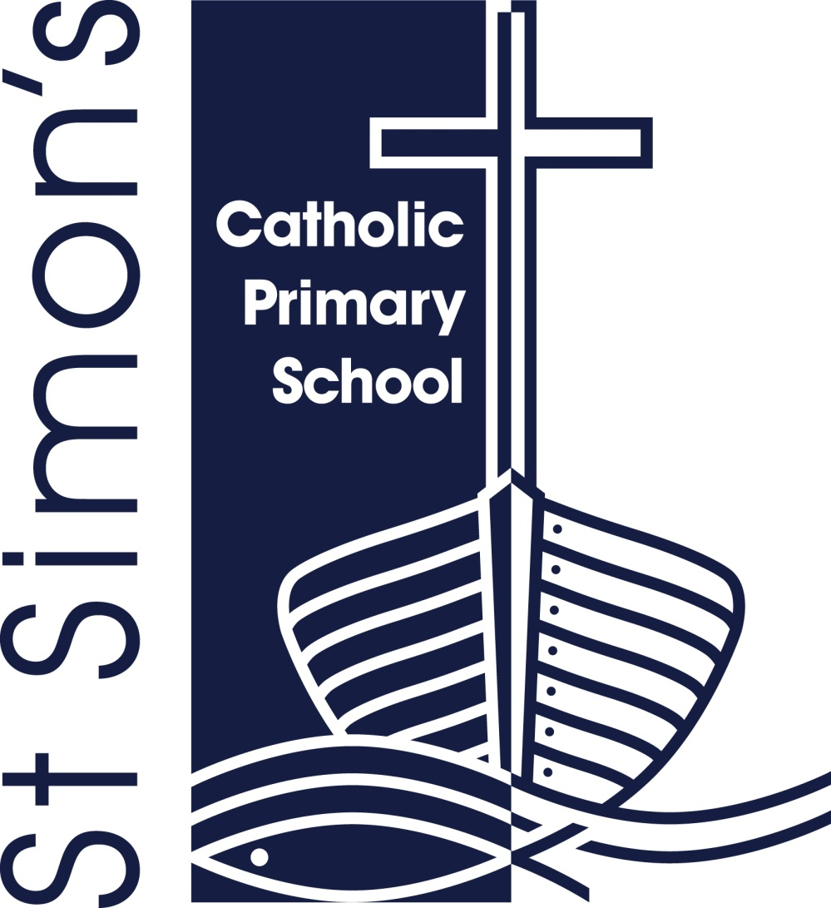

*St Simon’s Catholic Primary School*

*‘Whatever we do, we do it for the glory of God.’*

**CONSULTATION ON SCHOOL ADMISSION ARRANGEMENTS 2026/27**

St Simon’s Catholic Primary School is carrying out a consultation on the proposed admission arrangements for admission in September 2026/27

Admission arrangements are the overall procedure, practices and oversubscription criteria used in deciding the allocation of school places. The consultation is being carried out by the governing body

**There have been no changes to the admission policies from previous years**

The Governing Body is fulfilling its statutory duty to consult at least every seven years

The proposed admission arrangements are published on the school’s website and can be viewed at

<http://www.st-simons.stockport.sch.uk> or by contacting

Mrs Crisp at Headteacher@st-simons.stockport.sch.uk

Any comments on the proposed admission arrangements should be sent to Name and Address, or email address.

The consultation opens on Friday, 29th November 2024 and closes on Thursday, 9th January 2025.