STATUTORY PROPOSAL FOR PRESCRIBED ALTERATION TO PRIESTNALL SCHOOL

  - Establishment of Specialist Resourced Provision (SRP) for pupils with Learning and Cognition or Social, Emotional & Mental Health (SEMH) needs

The School Organisation (Prescribed Alterations to Maintained Schools) (England) Regulations 2013
- School and LA details
School: Priestnall School
Address: Priestnall Road, Heaton Mersey, Stockport, SK4 3HP
Local Authority: Stockport Metropolitan Borough Council

- Description of alteration
  - Stockport Council proposes to establish specialist resourced provision (SRP) for pupils with learning and cognition, or social, emotional and mental health needs at Priestnall School from September 2023.

  - The new provision will be based at the current site within newly built provision. Remodelling of existing space may be required however it is unknown at this stage whether additional building works beyond the creation of the resource base itself will be required. Depending on the timescales for design, planning and obtaining consent for building works, the formalised space for the SRP may not be available until September 2024.

- Implementation

  - If the proposal is agreed, it is planned to undertake design/technical, remodelling and building work during the 2023/24 academic year.

- Evidence of demand
  - Pupil numbers in early years and primary phases peaked in 2018 and have since been falling and will continue to fall until 2028. Projections suggest that pupil numbers in the primary phase will not recover to 2018 levels until at least 2037.

  - High pupil numbers in the primary phase have and will continue to feed into the secondary phase. A peak in pupil numbers in the secondary phase is expected in 2026. Pupil numbers will fall gradually reaching their lowest levels in 2033.

  - Nationally the Office and National Statistics (ONS) and Department of Education jointly project that demand for high needs places will begin to fall in 2024. Stockport’s own projections indicate growth at an upper level of 2.85% per year in the size of the SEND cohort and those requiring high needs places. Early indications suggest this demand will fall away from 2027.

  - In Stockport we have historically been an outlier in relation to EHCP plans issued and maintained.
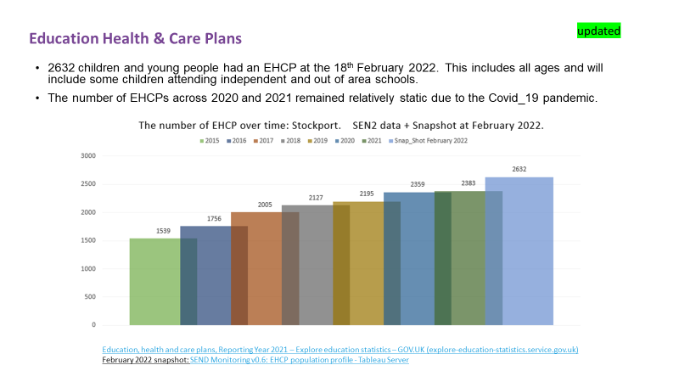
  - Stockport has above average EHCP rates. This corresponds to historically lower SEN support numbers.

  - There is evidence to suggest that levels of SEND need are in part linked to deprivation, particularly in respect of lower-level SEN support. The proportion of children and young people with an EHC Plan or receiving SEN support in Stockport are more than twice as high in the most deprived areas compared to the least deprived.
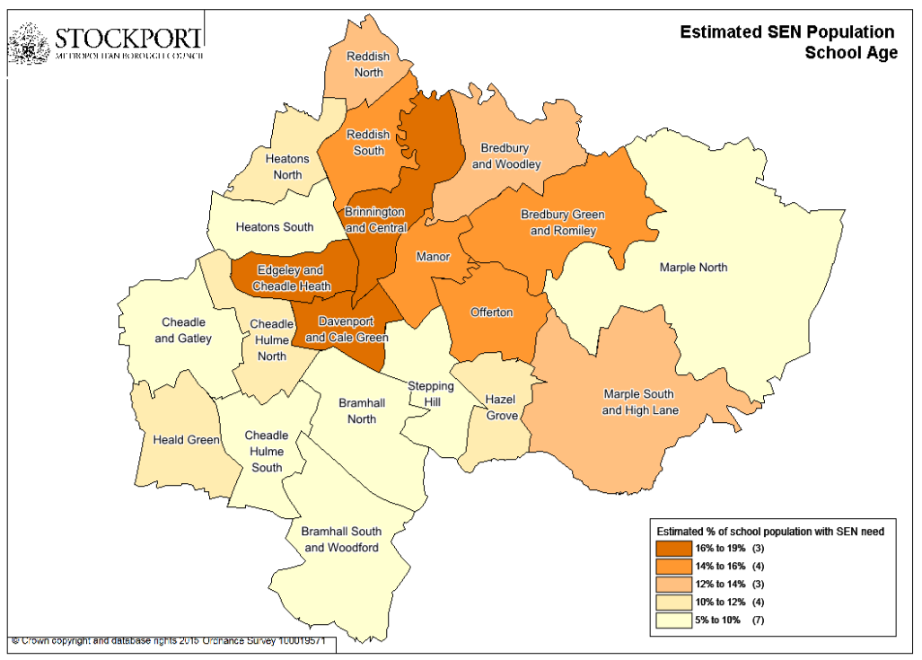
  - In terms of types of primary need of our SEND pupils these can be seen below. In most categories of need the numbers have been in line with the population projections. However there has been a specific rise in Autism Spectrum Disorders (ASD) and Social Emotional and Mental Health (SEMH), up 26% and 17% respectively since 2018/19. Speech, Language and Communication Needs figures are also high, increasing 17% since 2018/19.

  - We have recognised the need to commission further resource bases so that each neighbourhood is served by at least two primary resource bases and a commitment to have a secondary school resource base nearby. In total an additional 8 primary and 3 secondary resource bases will be commissioned over 21/22 and 22/23 academic years. This will create 96 new places in primary phase and 90 places in the secondary phase.

- Objectives
  - Special Education Needs and Disability (SEND) provision
    - The SRP will be physically designed to be flexible and able to meet the needs of children with learning and cognition needs or have social, emotional and mental health needs. It is likely that as the local profile of need changes over time that the use of the resource base may change to ensure it meets local need.

    - Initially, the SRP will be set up for children with a primary need of SEMH stated on their Education, Health and Care Plan (EHCP). The provision will enable the increasing number of pupils with SEMH needs to benefit from attending a mainstream school, whilst also receiving specialist input for SEMH relevant to the child’s needs.

    - Pupils that are allocated a place at the SRP will benefit from an individualised nurture group-type programme with a regularly reviewed support package. Staff will deliver a differentiated curriculum and use materials and approaches which promote the best possible academic, social and emotional outcomes for pupils.

    - The allocation of places to the SRP will be decided by the Stockport Council’s SEND service. There will be no priority to the SRP for existing Priestnall School pupils applying for a place at the SRP, as is the case for other children on roll at mainstream schools with autism resource bases.

  - School Organisation Principles
    - Stockport Council has an enduring statutory duty to provide sufficient school places for Stockport resident children. In recommending this proposal to establish an SRP at Priestnall School, Stockport Council should have regard to the borough’s School Organisation Principles. The principles relevant to this proposal are outlined below.

      - School Changes. Stockport Council will support viable expansions of popular and successful schools in line with Department for Education (DfE) policy wherever possible. In planning for changes to school organisation such as expansion, amalgamation, federation and closure, Stockport Council will take into account the factors such as popularity, Ofsted rating, condition issues, surplus places, the schools finances, other factors such as ability to withstand significant change focussing on leadership.

      - Quality and diversity. Stockport Council will seek to ensure that sufficient, attractive, high-quality state-funded school provision is available within the borough to meet the needs of all children. As outlined in One Stockport Borough Plan.
      - School budgets/finances. Stockport Council will consult with schools prior to the implementation of any changes to funding of maintained schools. The funding will be allocated in line with the Operational Guidance, School Funding Regulations and endorsed by Schools Forum.
      - Education estate. Stockport Council will seek to ensure that school premises are well maintained, fit for purpose and meet all relevant national standards for space and health and safety.

- Project costs and funding
  - The approximate budget (pending design and technical works) for the capital works at Priestnall School to accommodate the SRP is £1,000,000 and will be funded through the High Needs Provision Capital Allocation. Funding will be allocated as outlined in the Council’s School Investment Plan. The SRP will not remove funding from the mainstream school, as it will be fully independently resourced.

- Consultation
  - A pre-publication consultation took place between 19 July 2022 and 21 August 2022 to inform this statutory proposal. Responses to the consultation were overwhelmingly supportive of the proposal despite the risks and mitigations presented to stakeholders.

  - A further round of public consultation is required as part io the statutory ‘representation’ stage of the statutory change process. This consultation and supporting documents are available here www.stockport.gov.uk/schools-consultations-and-statutory-proposals

- Decision-making
  - The decision-maker for this proposal is Stockport Council’s Cabinet, in the event that no objections are received. A decision must be made within a period of two months of the end of this consultation period.

- Objections and comments
  - Any person or organisation wishing to submit any comments either in support of, or objecting to, the proposal is encouraged to engage with the consultation as referenced in section 7. However you may also do so by sending them to:
School Organisation Team, school.organisation@stockport.gov.uk
  - Comments must be received before 11:59pm Sunday 4 December 2022

