Appendix 2- Rationale for reduction in the Published Admission Number for Abingdon and Vale View Primary Schools, Reddish.

The Local Authority are proposing a reduction in the Published Admission Number (PAN) for Abingdon Primary School from 60 to 45 and Vale View Primary School from 45 to 30 due to decreased demand for places in the Reddish Area.
Stockport are seeing a decline in birth rate of between 6 and 8% with North Reddish seeing a drop of 7% and South Reddish 9%. The Local Authority want to ensure this does not affect the financial viability of the schools in the Reddish area and the proposed reduction in PAN will allow the schools to continue meeting the needs of their local communities, whilst also ensure the long term financial position of the school remains tenable.
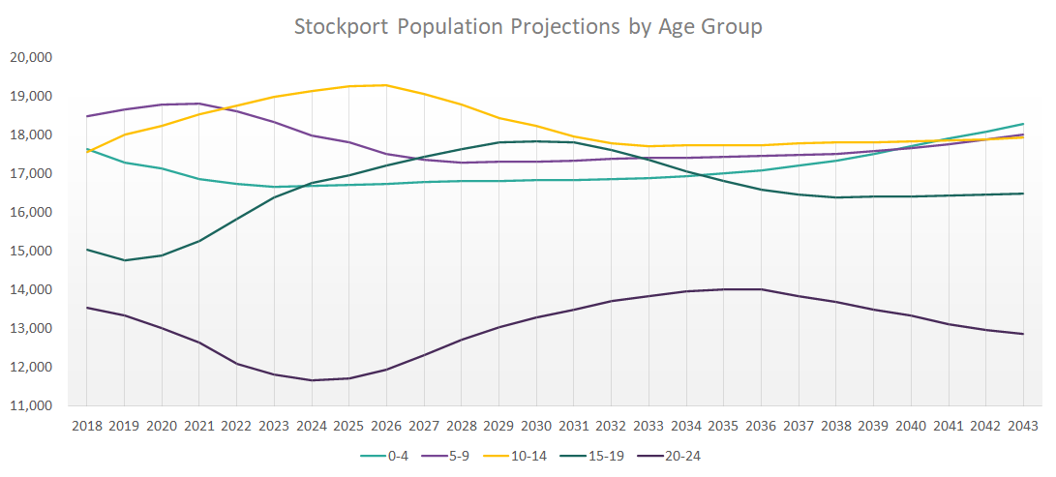

Abingdon Primary are proposing to reduce their PAN from 60 to 45, allowing them to operate with less classes overall. This reduction is in line with the current numbers on role for the school:
Reception- 36
Year 1- 47
Year 2- 46
Year 3- 29
Year 4- 41
Year 5- 47
Year 6- 49

Vale View Primary are proposing to reduce their PAN from 75 to 60, allowing them to operate as a two form entry school. This reduction is in line with the current numbers on role for the school:

Reception- 49
Year 1- 48
Year 2- 56
Year 3- 61
Year 4- 67
Year 5- 62
Year 6- 64

Birth rates are expected to remain stable at the current rates for around 10 years, which would leave the schools running at a financial deficit long term if the proposed changes are not made.
Reducing the PAN for both schools will provide an opportunity for the schools to manage their budget and resources to ensure the schools remain open for local children.

